Fire Detection Using OpenCV and CUDA

Wissam Antoun
Maroun Semaan Faculty of Engineering and Architecture
American University of Beirut
Beirut, Lebanon
wfa07@mail.aub.edu

Abstract – In this paper, a high frame rate fire detection system was implemented using OpenCV and NVidia CUDA. Parallel implementation of serial OpenCV functions are used to accelerate the serial code.

Index Terms – Fire Detection, OpenCV, CUDA, Image Processing.

I. Introduction
With continuing rise of cites and urban areas, fire hazards will also rise and causing increasingly higher damage. Up until this day, Fire Detection still relies on hardware specific sensors, these sensors are usually slow since the smoke has to hit the ceiling before these sensors can detect it, other sensor rely on temperature which is the slowest since the damage will already be done by the time the sensor had detected it. Also, these sensors can’t handle large areas such as forests or highways. Urbanization, also caused a rise in video surveillance and monitoring, which can be used to detect early starts of fire. The suggested approach is using the already existing Security Cameras Infrastructure to detect smoke at high frame rate to reduce latency. GPUs (Graphics Processing Units) recently became popular in parallel computing platforms, with CUDA (Compute Unified Device Architecture) created by NVIDIA[1] that provides a programming framework to enable the execution of C function kernels on GPUs[2]. Using CUDA will allow the algorithm to run at these high frame rate, since the video stream will be in HD, since CPUs can’t handle the amount of data generated by the camera feed. The algorithm will rely om color analysis and other image processing techniques to identify the Fire. This algorithm can be used in flying swarms of drones, that can be programed to monitor large forests, since the performance and FPS should be high enough to allow for Real Time Detection and tracking.
II. Related works
There are several methods proposed in the literature to detect flames, by using various image processing techniques.
Phillips et al. [3] and Healey et al. [4] relied on the variation of color with time, while Chen et al. [5] relied on the sudden movements of flames, changeable shapes, growing rate, and oscillation (or vibrations) in the infrared response to confirm the existence if fire. Straumann et al. [6] and Liu et al. [7], used Fast Fourier Transforms of fire boundary pixels. Wang et al. [8] proposed a fire detection system based on smoke detection in video streams.
Wang et al. [9] proposed a TBB-CUDA (Thread Building Blocks) implementation for Background Removal in a Video-Based Fire Detection System where they achieved 9 times speedup over a serial implementation. Hamzaçebi [10] presented a CUDA-based implementation of flame detection in day and IR videos, that used a covariance matrix of 3 consecutive frames containing flame pixel, then feeding the output into an SVM for the final decision, they achieved 10 FPS on a 960x720 video resolution on the GPU vs 3.4 FPS on the CPU.
This project uses a purely color-based model which uses characteristics, since the intended use case is in detecting and tracking fire in large forest and mostly uniformly colored areas, using multiple video stream from multiple drones simultaneously (off-loading the processing of the stream for the drone to a remote GPU-equipped server which saves precious battery power).
III. Fire Detection system using CUDA
In a vision-based fire detection system, at first the image is captured. Since the project focuses on a low-cost solution, it is suggested to use normal video surveillance camera to capture the image. Then the captured image is converted to suitable color space. Noise reduction is performed on the image using a median blur filter (it applies median value to central pixel within a kernel size). Thresholding is then applied on the image where pixels that falls in a certain color range that corresponds to fire. Thresholding will result in a lot of noisy pixels or some group of pixels that are close to each other but don’t form a single object. The erode function will reduce the noise while the dilate function will make the objects more visible. The findContours() function will analyze the binary image to retrieve objects and shapes, the system will only focus on objects that are relatively big in size (over 20px by 20px). An FPS counter was implemented to measure the performance of algorithms that are implemented on the CPU and the GPU. A visual representation of the algorithm is shown below in Fig. 1.
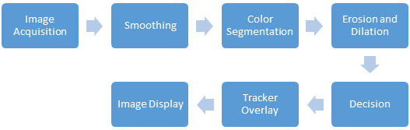
Figure 1. Fire Detection Algorithm

Since most of the algorithm is based on image processing, some function will be able to benefit from parallel processing to speed up the execution. The parts or blocks shown in red in Fig. 2 highlights the functions that can be parallelised. In this project NVidia CUDA was used to write paralysed part of the algorithm.
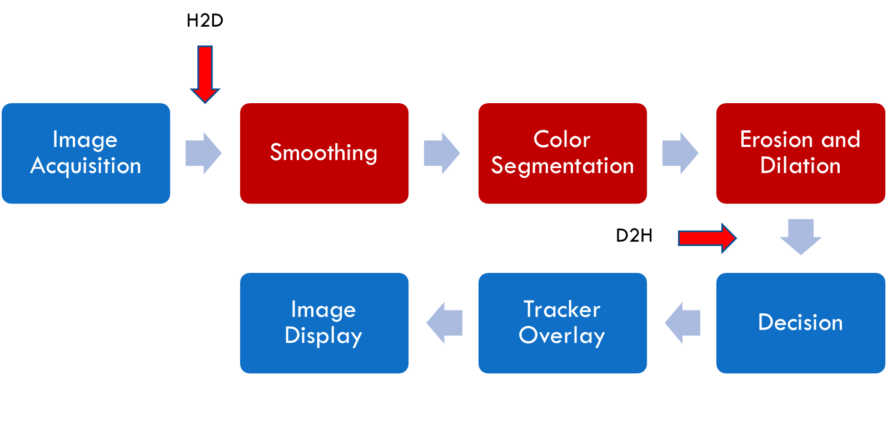
Figure 2. Fire Detection Algorithm / Parallelised Blocks

Smoothing: A smooth filter or a low pass filter is the basis for most smoothing methods. An image is smoothed by decreasing the disparity between pixel values by averaging nearby pixels.
- CPU: cv::medianBlur() function takes the median of all the pixels under kernel area
- GPU: TiledMeanBlur() written using CUDA C, each thread will load one of the needed pixels (Output pixels + Halo), and only threads within the Output tile will be computing the mean using a Mask that was copied earlier in the initialisation phase into the constant memory to guarantee faster access to it.

Colour Segmentation: Also called thresholding, checks if array elements lie between the elements of two other arrays (lower and upper bound array)
- CPU: cv:: inRange() function will output a new array that contains only 1 channel with 255 where the original pixel passes the check and 0 otherwise.
- GPU: GPU_inrange() written using CUDA C, each thread will check if the one pixel is in the range of the supplied arrays.

Erosion: Compute a local minimum over the area of the kernel, so bright areas of the image will get thinner thus removing small noise dots as shown in Fig. 3.

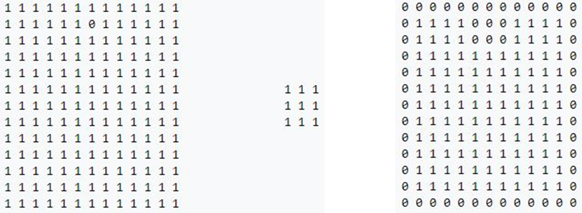
Figure 3. Erosion
- CPU: cv::Erode(), the erode function is used twice in a row to provide better noise removal.
- GPU: TiledGpuErode(), written using CUDA C, each thread will load one of the needed pixels (Output pixels + Halo), and only threads within the Output tile will be checking if one of the value under the Kernel is zero then the central element will replaced by a zero else it will be replaced by 255.

Dilation: Compute a local maximum over the area of the kernel, so bright areas of the image will get bigger thus overlapping and join objects that are close to each other as shown in Fig. 4. Same implementation as Erode but with an inverted output condition and value.

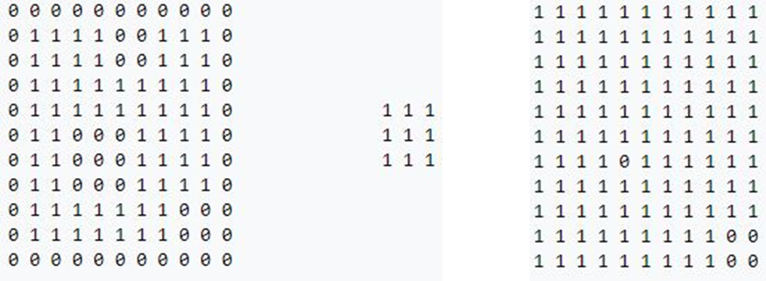
Figure 4. Dilate
Decision: The decision is based on the minimum size of the object found in the Threshold matrix after applying the cv::findcontours() function that stores all objects in the matrix in a vector. Also if the function outputs more than 50 objects then the filter isn’t accurate and will need adjustments to boundary arrays or the filter masks. Detected Objects will have their coordinates stored in a Vector that will later be used to overlay the tracker on the original image.
IV. Implementation and Experimental setup
The source code will first define and initialize all variables that will be needed in the detection Loop:
- BLUR, DILATE and ERODE masks and their respective Kernel Parameters.
- Minimum detected object area and the noise filter validator
- Capture Streams for Video streams
- Host Matrices allocation used for frame storing and manipulation and masks
- GPU device Memory allocation
- Fps counters
- Threshold Boundaries
- Kernel Grids and Blocks
After initialization, a loop will feed the video frames into the detection algorithm where 2 implementations (one serial and the other parallel) were implemented and later compared. The threshold frame and the original frame with marker superimposed on it are then shown on the screen.

Computer Specs:
- Intel® Core™ i5-6600 Processor (6M Cache, up to 3.90 GHz)
- 8GB DDR4 2166MHz RAM
- 5600RPM 1TB HDD
- GTX 970 1050 MHz 4GB GDDR5 1664 CUDA Cores

Video Stream:
- 3840x2176 frame resolution
- 14.4 Mb/s bitrate at 29.970 fps
- 1 min 4s
- .avi Format

Kernel Params. :
- BLUR_Mask_width 5
- DILATE_Mask_width 9
- ERODE_Mask_width 3

- BLUR_O_TILE_WIDTH 12
- DILATE_O_TILE_WIDTH 8
- ERODE_O_TILE_WIDTH 14

- BLUR_BLOCK_WIDTH 16
- DILATE_BLOCK_WIDTH 16
- ERODE_BLOCK_WIDTH 16
- InRange_BLOCK_WIDTH 16

- BLUR_GRID_SIZE 320x180
- DILATE_GRID_SIZE 480x270
- ERODE_GRID_SIZE 275x155
- InRange_GRID_SIZE 240x135

Threshold Boundaries:
- BLUE_MIN = 40;
- GREEN_MIN = 0;
- RED_MIN = 95;

- BLUE_MAX = 256;
- GREEN_MAX = 95;
- RED_MAX = 256;

Software:
- OpenCV v2.4
- CUDA 8
- Visual Studio 2015 Community
V. Results
Using the Fps Counter and the NVidia Visual Profiler, a quantitative data is provided below. A 4K video file taken from a flying drone is used as input.
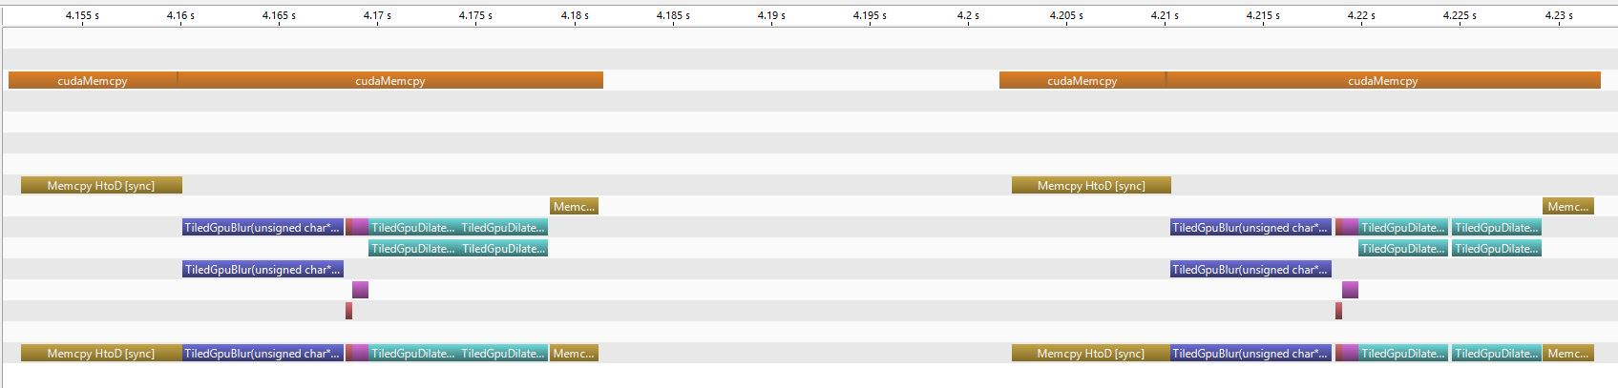

Figure 7. NVidia Visual Profiler Output Graph
Fig. 5 below shows a frame with the tracking overlay.
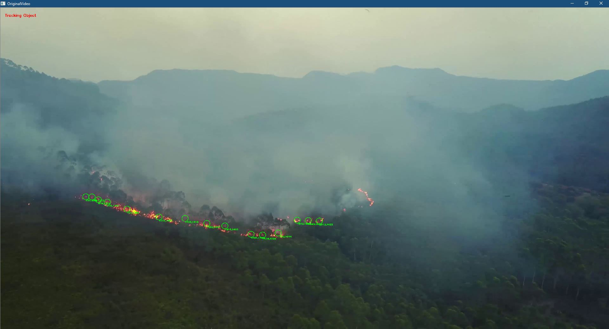
Figure 5. Tracking Overlay
Fig. 6 below shows a Threshold frame after dilate and erode.
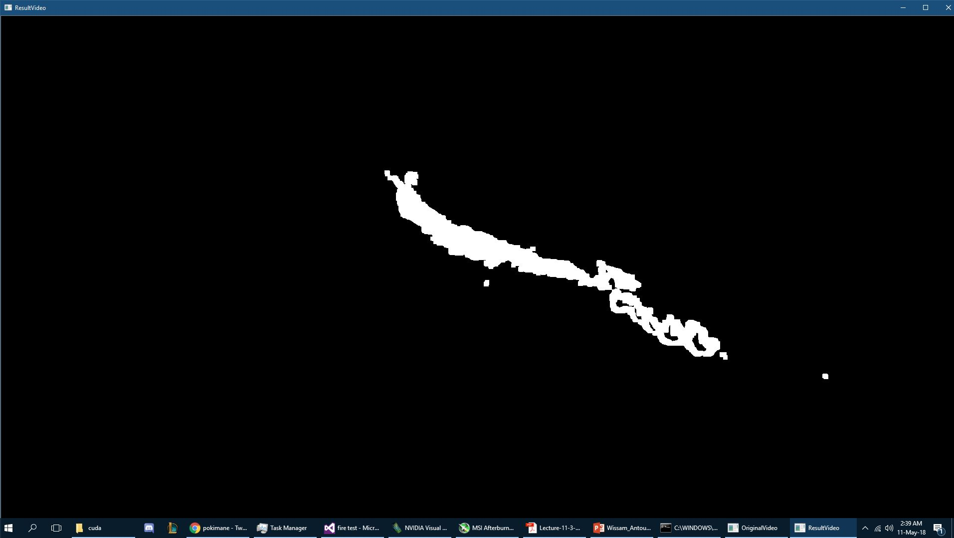
Figure 6. Threshold frame after dilate and erode

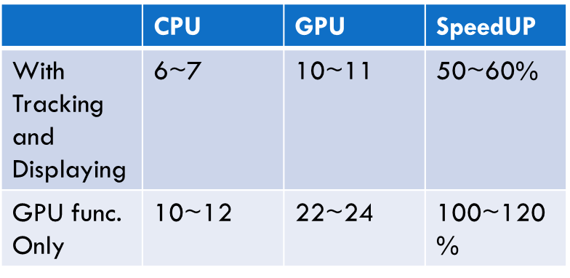
Table 1. FPS Comparison between different parts of the algorithm

Table 1 shows that the algorithm that uses GPU is ~60% faster than the CPU only approach. The functions that got accelerated on GPUs ran with twice the speed, but according to Amdahl's law this speed up will only be applied to part of the program. Since loading the image, tracking the objects, drawing the overlay and displaying back the image are still running in the CPU and haven’t been touched. We can clearly see the delay in the CPU execution part using NVidia profiler, shown in Fig 7.

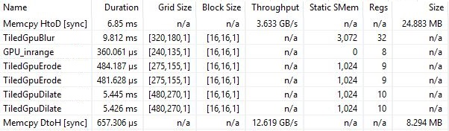
Table 2. Execution Results and Parameters

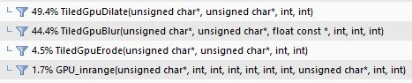
Table 3. Execution Percentages

Table 3 and 4 as well as Fig7. shows that the majority of GPU execution time is in The BLUR and the 2 Dilate functions, also the memory copy from Host to Device is Taking A considerable time compared to output image that is copied from Device to host, this because the output file is 3 times smaller (1 channel instead of 3) and the also because the output file uses pinned memory which greatly increase the throughout from 3GB/s to the full PCI-E Gen 2 Bandwidth of 12.6 GB/s.
VI. Conclusion and Future Works
Fire detection systems are vital in saving people's lives and preventing hazards before they get out of control. In this project it was shown that using GPUs when doing image processing will greatly speedup the performance. This system can in theory be implemented on a mainframe that processes video feeds coming from multiple drones in a fleet flying around a forest fire, since a 4K stream is comparable to 4 FHD streams or more HD streams. For future works, and to get better results, CUDA streams can be implemented m which will cover or hide the time taken by the CPU execution and the memory copy latency.

CUDA code can be found in this Link:
https://github.com/WissamAntoun/Cuda-Kernels/tree/master/Fire%20Detection%20CUDA

References
- NVIDIA, CUDA C Programming Guide, v. 3. 2. Nvidia Corp.,2010.
- S. Zhang, Y. Zhu, and K. Zhao, GPU High Performance Computation-CUDA,Water Power Press, Bei Jing, China, 2009.
- W. Phillips, M. Shah, and N. Lobo. Flame recognition in video. PatternRecognition Letters, 23:319{327, 2002.
- G. Healey, D. Slater, T. Lin, B. Drda, and A. Goedeke, A system for real-time fire detection," pp. 605-606, 1993.
- T. Chen, P. Wu, and Y. Chiou. An early fire-detection method based on image processing. In Proceedings of the IEEE International Conference on Image Processing (ICIP), pages 1707{1710, 2004}.
- W. Straumann, D. Rizzotti, and N. Schibli. Method and Device for Detecting Fires Based on Image Analysis. European Patent EP 1,364,351, 2002.
- C. Liu and N. Ahuja. Vision based ¯re detection. In Proceedings of the International Conference on Pattern Recognition (ICPR), volume 4, 2004
- D. -J. Wang, Y. -H. Yin and T. -Y. Chen, "Smoke Detection for Early Fire-Alarming System Based on Video Processing," Journal of Digital Information Management, 2008. 6(2).
- Fan Wang, Xiao Jiang, and Xiao Peng Hu, “A TBB-CUDA Implementation for Background Removal in a Video-Based Fire Detection System,” Mathematical Problems in Engineering, vol. 2014, Article ID 692921, 6 pages, 2014.
- Hasan Hamzaçebi, Cuda Based Implementation of Flame Detection Algorithms In Day And Infrared Camera Videos, a thesis submitted to the department of electrical and electronics engineering and the graduate school of engineering and science of bilkent university in partial fulfillment of the requirements for the degree of master of science

